AFFIRMATION OF ISOLATION
Complete if you or your child has tested positive for COVID-19 and have been in isolation (use a separate form for each positive person)

I, (print name) __________________________________________, do hereby affirm that my child isolated from

(date)____________________ through (date) __________________ consistent with guidance issued by the New

York State Department of Health (NYSDOH). As per NYSDOH guidance, since I or my child tested positive for COVID-19, Iormy childremained isolated fromother people at least5 days from the onsetof COVID-19symptoms OR fromthe dateofthe positiveCOVID-19test ifasymptomatic,whichever dateis earlier(Day1ofisolation begins the day after I or my child became symptomatic OR the day after I or my child tested positive if I or my child were asymptomatic) and symptoms significantly resolved.

Name of COVID-19 Positive Person: _____________________________________________________________

Date of Birth of COVID-19 Positive Person: ________________________________________________________

Date of Specimen Collection for Positive Test: _____________________________________________________

Symptom Onset Date (if earlier from Date of Specimen Collection for Positive Test): ______________________

Affirmed under penalties of perjury by me on (today’s date) ___________________.

I swear or affirm that the information in this “Affirmation of Quarantine is accurate, true and complete to the best of my knowledge. I understand that if I have knowingly made a false statement herein, I may be subject to prosecution under New York State Penal Law 210.45. I am responsible for providing all correct information including full name, date of birth, email address, mailing address, and phone number on this form. I understand that pursuant to the Electronic Signatures and Records Act (ESRA), the use of an electronic signature shall have the same validity and effect as a signature by hand.

Parent/Guardian signature: _________________________________________________________________________________________

If completed fully and accurately, based solely on such provided information which I accept as fact, I, Marcas Flindt, Director of Public Health, Chenango County Health Department, do hereby find that the affirming individual herein has met the criteria for isolation if the date this form is affirmed is more than 10 days from the listed isolation period onset date.

Marcas W. Flindt RN, MSN Director of Public Health

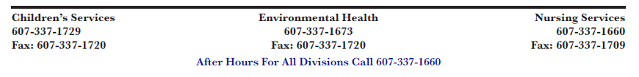
This form may be used for Isolation Release or for New York Paid Family Leave COVID-19 claims as if it was an individual Order for Isolation issued by the Chenango County Health Department Commissioner of Health.

